KostalPiko 4.2 Reader

- Webscraping from KostalPiko Inverter
- MQTT publish
- Web interface for all
  - Wifi,
  - MQTT,
  - OTA &
  - KostalPiko inverter settings
- CSV and JSON file download

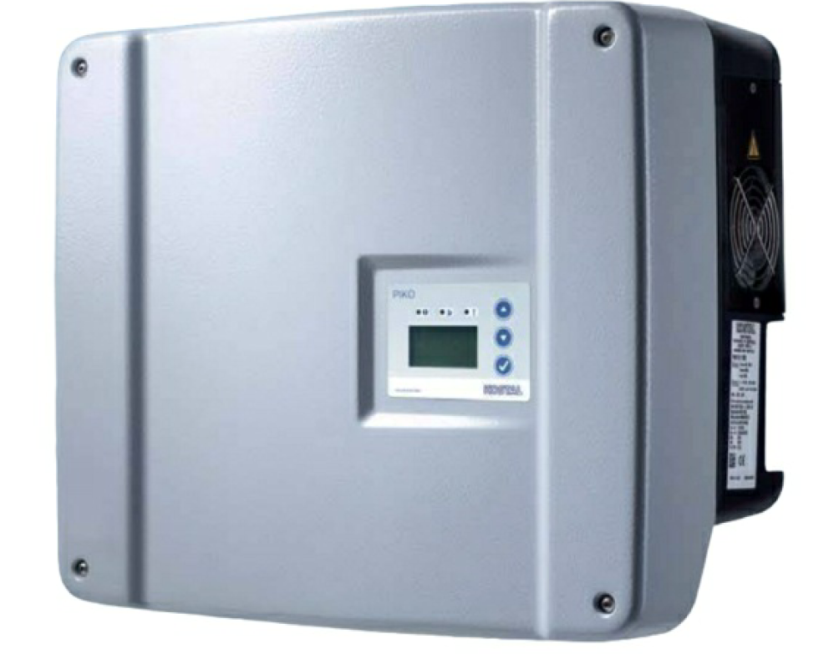

Table of Contents
1.1 KostalPiko 4.2 Reader Highlights 4
2 Naming 5
3 Important information 5
4 Hardware functionality of the KostalPiko Reader 6
4.1 Button 6
4.2 LED 6
5 Software functionality of the KostalPiko Reader 8
5.1 Internal File system (LittleFS) 8
5.2 Flash chip 8
5.3 Internet functionality 8
5.3.1 Internet/Wifi 8
5.3.2 Access Point 8
5.3.3 Login 8
5.3.4 Internet clock (NTP server) 9
5.3.5 Webpages 9
5.3.6 MQTT 9
5.4 System Settings 9
5.5 Software setup() and loop() 9
5.6 Setup() 9
5.7 Loop() 10
5.8 KostalPiko value correction 11
6 Usage of Flash memory 12
6.1 User interaction with the stored data 12
6.2 JSON file specification 12
6.3 CSV file specification 13
6.3.1 During power-on 13
6.3.2 Actions during day change 14
6.3.3 Remove data of one day 14
7 Hardware 15
8 Webpages 16
8.1 Main webpage (index.html) 16
8.2 KostalPiko_values 17
8.3 Memory 17
8.4 KostalPiko Settings webpage 17
8.5 KostalPiko network credentials 18
8.6 Reset 20
8.7 Login manager 20
8.8 WifiManager 21
8.9 MQTTManager 22
8.10 Webpage hierarchy 23
8.11 OTA programming 23
9 ESP8266-12 (ESP8266MOD) pinning 24
10 First Start of the KostalPiko Reader 25
10.1 Fully erase the KostalPiko Reader 25
10.2 Connecting to your home network 25
11 Used libraries/plugin’s in Arduino IDE 27
11.1 Littlefs upload, For uploading HTML, CSS, JS and text files 32
11.2 ESP Exception decoder 32
12 Problems/To do 33

KostalPiko 4.2 Reader Highlights
Functions list:
- Created for and only tested on a KostaPiko 4.2 Inverter
- Create at first start an Access Point for Wifi connection
- Let user connect device to their own home network. With static or DHCP IP number
- Read time from NTP server.
- Holds webserver with webpage to control and view status of the KostalPiko Reader
- Connect to MQTT to publish values
- Access to KostalPiko Reader is protected by a username and password.
- Reads KostalPiko values from website of KostalPiko inverter
- Webpage with KostalPiko values (all readonly)
- Webpage for setting wifi credentials
- Webpage for KostalPiko device credentials
- Webpage for setting MQTT credentials
- Use LED in flashing mode for special functions.
- Storage of KostalPiko device values in flash memory
- Overview of what is in onboard memory
- Storage for 128 days
- Use pushbutton for full reset
- Read KostalPiko values via CSV or JSON file
- Status of KostalPiko
- Programming via RS232 of OTA (password protected)

Naming
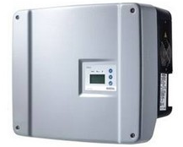
In this document two device are mentioned:
Figure 1 Kostal-Piko device
- KostalPiko device (inverter). The device that is connected to the solar panels and converts the power from the panels to the power lines in your home. Although it has a web interface, automatic downloading and viewing in for example Home Assistant is not possible or difficult.
Only KostalPiko 4.2 is supported.
- KostalPiko reader. The reader reads the values from the KostalPiko device webpage and makes them visible through MQTT and the internal webpages. This device holds a ESP8266 processor and is connected via Wifi to your home network. Settings for the network connections can be made through the webpages of the KostalPiko device. See chapter 8 for more info.

Important information
- No internal battery in the KostalPiko Reader
- All settings and data are stored in internal flash memory or ESP8266. No storage in the cloud.
- No connections to external web sources. All HTML, CSS and Javascript files are inside the KostalPiko Reader.
- No information is sent to the external world. Everything is kept locally.

Hardware functionality of the KostalPiko Reader
The most important parts for the hardware of the KostalPiko reader are:
- ESP8266 processor. Holds all the software to read values from the KostalPiko device and makes them visible to the outside world. All Wifi, MQTT and KostalPiko device credentials can be set via the internal webpages.
- A flash memory device for storage of values from the KostalPiko device.
- Power supply.
- A button and a LED.

Button
- Press of 5 seconds on the button will reset the KostalPiko Reader completely. All network settings and the flash memory will be erased. This takes a maximum of 30 seconds. Reconnection to the reader via an Access Point.
- Button pressed are handled by interrupt.
- The LED is also used when the pushbutton is pressed. Every second the button is pressed, the LED will light for a short period, which makes counting easier.

LED
The LED will be used in several ways. During start-up of the KostalPiko, the hardware is tested for correct functionality. The next table shows how the LED is used.
Occurrence | Time on  (sec) | Time off  (sec) | Number of  flashes | Remark
Power on | 0.5 | 0 | 1
File system LittleFS not found | 1 | 5 | Forever | This is the file system that is used to store all kind of settings from the KostalPiko. Without connection the KostalPiko Reader will not work correctly.
Wifi not found (wifi type = 0) | 2 | 4 | Forever | Without Wifi, NTP can also not be started. It is essential for the KostalPiko.
NTP server not found | 3 | 3 | Forever | If the time server cannot be reached, no data can be stored in the Flash memory, because no time stamps are available in Flash.
MQTT not found | 4 | 2 | 3 | MQTT can be used to send values to the MQTT server. Because a lot of people will not have MQTT, this is not a required feature.
Flash memory not found | 5 | 1 | Forever | Flash memory is used to store electrical value. If there is no free room anymore, a warning will be given. KostalPiko will work normally but will not store electrical values unless memory is freed.
Flash memory full | 4 | 2 | 5
When the software loop starts | 1 | 1 | 2 | Signals that the setup is done and the loop starts.
Reading the webpage of the KostalPiko (every minute) | 0.5 | -- | 1 | Every time the KostalPiko device webpage is read

During the software startup a lot of connections and hardware parts are started. If a part cannot be started or is not function well, this can be seen as an error, because it stops some functions from the KostalPiko Reader.

Software functionality of the KostalPiko Reader
Software for the KostalPiko Reader is written in C++ and is created by using the Arduino IDE environment. A number of external libraries is used and they are defined in chapter 11.

Internal File system (LittleFS)
File system is used to store:
- html files (17 files)
- style.css file. All html files use the same style.css file (1 file)
- Icons for webpage (2 file)
- Files for login credentials (2 files)
- Files for Wifi credentials (8 files)
- Files for MQTT credentials (4 files)
- Files for KostalPiko device credentials (3 files)
- File for Ota password (1 file)

Flash chip
A large Flash memory (128Mbit/16MByte) is used to store KostalPiko values in memory. At a later time, these values can be read as a CSV or JSON file. See chapter 6.

Internet functionality

Internet/Wifi
Internet connection is used for:
- Starts with an access point (AP)
  - User can create connection to own network with dynamic IP
  - User can create connection to own network with static IP
- NTP server, to be able to store electrical value with time stamp
- Publish mqtt messages
- Webpages for the KostalPiko
- Reading CSV and/or JSON files with KostalPiko device values
- Settings credentials

Access Point
When the KostalPiko reader is started for the first time it creates an Access Point. Use a mobile device (laptop, telephone, tablet) to make a connection to this access point. The network that you should see is something like kostalpiko-xxxx, where xxxx is a 4 digit number, randomly generated between 1000 and 9999.

Login
The KostalPiko web pages are protected by a user login with “Username” and “Password”. Default both values are empty. The user can change and is advised to change this “Username” and “Password” to prevent unauthorized access.

Internet clock (NTP server)
Date and time are read from the NTP server and are used for timestamping KostalPiko values stored in flash memory. Date and time are also shown on the top of every webpage. Time zone is Amsterdam and fixed.

Webpages
All webpages are stored in processors memory of the KostalPiko Reader. Also, a CSS file is stored there to give every webpage the same look. In the webpages are so called Placeholders (terms as %....%). These terms are replaced by numbers/text or dates by a piece of software called “processor”, before the webpage is shown in a browser. In this way webpages are a little bit dynamic. Every 1 minute the date and time and sometimes the content of a webpage is refreshed.

MQTT
Via MQTT electrical values will be published to the MQTT broker. The following values will be sent:
- Current Power (W)
- Total Energy (kWh)
- Daily Energy(kWh)
- String1_voltage
- String1_current
- String2_voltage
- String2_current
- String3_voltage
- String3_current
- L1_voltage
- L1_power
- L2_voltage
- L2_power
- L3_voltage
- L3_power
- Status for the KostalPiko device (“MPP” or “noMPP”). MPP means delivering energy to the net.

System Settings
- Network name of the device. Does not work for Static IP

Software setup() and loop()
Using the Arduino IDE, there is a strict division between the setup and loop part. Both parts are described below.

Setup()
The following actions are performed here:
- Set serial connection and speed for debugging (serial) port
- Check if the littlefs file system exists
- If littlefs exists, read files for wifi and mqtt communication.
- Read files for login credentials
- Start the wifi connection depending of the files found in littlefs
- Start the webserver
- Start the timeserver
- Start the connection with the flash chip and find some free area to store electrical values
- Depending on the wifi type and the values for MQTT, start the MQTT connection.
At the end of the setup() routine the following flags are available
- wifi_type. What type of wifi connection do we have.
  - 0 = no wifi connection
  - 1 = Station mode with static IP
  - 2 = Station mode with dynamic IP
  - 3 = Access Point mode
- mqtt_ok. False if no connection can be made to the MQTT server or if wifi_type = 0.
- ntp_ok. False if no connection can be made to the time server or if wifi_type = 0 or 3.
- littlefs_ok. False if no file system can be found or files cannot be read.
- flash_ok. If flash chip is found and RDID and REMS values are correct.
Rules:
- If wifi_type = 0, there will be no other actions. No webserver, led will flash.
- If wifi_type = 3, no mqtt, no ntp and no flash actions will take place. Webserver will work.
- If wifi_type = 1 or 2, further checks will be done.
- If littlefs_ok = false, there will be no other actions. Led will flash.
- If mqtt_ok = false, no data will be sent to the mqtt broker. If “true” values will be sent to the MQTT broker
- If ntp_ok = false, there will be no other actions. Led will flash.
In general: Messages will be shown on a webpage, otherwise the LED will blink.

Loop()
Main loop runs on the external clock (ntp), if external time is available. Otherwise, the internal clock (millis) is used.
Main loop runs every minute and start with:
- Connection to Wifi, ntp and MQTT is checked and if not available an attempt to reconnect is done. (still to implement)
- If MQTT is active, values are published, Values are written into Flash memory
- Led is driven
- If erase flag is active a datagroup is erased.
- If restart flag is active the KostalPiko is restarted.
Request for webpages and updates of them is done asynchronously on the background.
Buttons and led are processed by interrupts

KostalPiko value correction
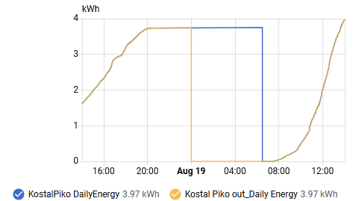
The Daily Energy value received from the KostalPiko device is an increasing value during the day. This value is set back to zero, not at the end of the day, but at about 5:00 PM. This means that the Daily Energy value from yesterday will appear in the graph of the Daily Energy of today, which give a completely wrong graph for this Daily Energy.
Figure 2. Modified Daily Energy
In the KostalPiko Reader a new Daily Energy (out_daily_energy) value will be calculated. The value sent to the Flash memory and to MQTT will be set to zero at 00:00, so just when the new day starts. This value will be kept at zero until the KostalPiko Device starts to generate energy to the net. Blue is the original graph of Daily Energy and yellow the corrected one. Which is send by MQTT and saved in flash memory.

Usage of Flash memory
A flash memory is used (W25Q128 – 16 MByte) to store values from the KostalPiko Reader. If people do not have an MQTT server they can read the stored values at a later time, to process the data in their own way. Output formats will be JSON and CSV. No file system is used for the flash device.
Some numbers:
- A datagroup stores data of one day and has the size of 128kBytes.
- With a Flash size of 16Mbyte, data for 128 days can be stored.
- A dataset stores the data of one sample in the flash memory and the size of it is, 64 bytes, which give in one datagroup 2048 datasets. Storing data every minute in total one day has 1440 datasets.
- One dataset is used to store the year, month and date of the dataset itself.

User interaction with the stored data
On a webpage will be shown for which date, data is available in the flash memory. The user can select to download the data as CSV of JSON file. The user can also erase/delete the data. When the memory is full no more data will be stored in flash memory and new data will be lost. See Figure 6.

JSON file specification
Format of the example JSON file. Text must be between " " (not “) but numbers does not need them. Characters must be in UTF-8 coding. Data is only available from the “on” time of the KostalPiko. Example file:

{
"date": "2026-01-15",
"format_version": "1.0",
"samples": [
{
"time": "00:00",
"flags": "0",
"Current_AC_Power": "200",
"Total_Energy": "12345",
"Daily_Energy": "123.45"
"Status": "MPP",
"String1_voltage": "262",
"String1_current": "0.64",
"String2_voltage": "226",
"String2_current": "0.65",
"String3_voltage": "0",
"String3_current": "0.0",
"L1_voltage": "222",
"L1_power": "154",
"L2_voltage": "219",
"L2_power": "0",
"L3_voltage": "219",
"L3_power": "129"
},

{
"time": "00:00",
"flags": "0",
"Current_AC_Power": "200",
"Total_Energy": "12345",
"Daily_Energy": "123.45"
"Status": "MPP",
"String1_voltage": "262",
"String1_current": "0.64",
"String2_voltage": "226",
"String2_current": "0.65",
"String3_voltage": "0",
"String3_current": "0.0",
"L1_voltage": "222",
"L1_power": "154",
"L2_voltage": "219",
"L2_power": "0",
"L3_voltage": "219",
"L3_power": "129"
}
],
"total_samples": 1440
}
The file downloaded will have the name <wifi network name>_<date>.json
Example: KostalPiko-7571_2026-01-16.json

CSV file specification
The file contains the following columns:
Time, Current_AC_Power(W), Total_Energy(kWh), Daily_Energy(kWh), Status(text), String1_voltage(V), String1_current(A), String2_voltage(V), String2_current(A), String3_voltage(V), String3_current(A), L1_voltage(V), L1_power(W), L2_voltage(V), L2_power(W), L3_voltage(V), L3_power(W), status
- Time is given as HH:MM.
- Flags is a number between 0 and 65535.

Example of the first part of a CSV file:
Time, Current_AC_Power(W), Total_Energy(kWh), Daily_Energy(kWh), String1_voltage(V), String1_current(A), String2_voltage(V), String2_current(A), String3_voltage(V), String3_current(A), L1_voltage(V), L1_power(W), L2_voltage(V), L2_power(W), L3_voltage(V), L3_power(W), Status(text),
07:13, 17,60189, 0.00, 238, 0.08,215, 0.07,0, 0.00, 220,0,220,0,220,17,1
07:14, 20,60189, 0.00, 241, 0.09,214, 0.08,0, 0.00, 220,0,220,0,220,20,1
07:15, 20,60189, 0.00, 236, 0.09,215, 0.07,0, 0.00, 220,0,219,0,220,20,1
07:16, 19,60189, 0.00, 240, 0.09,206, 0.08,0, 0.00, 219,0,218,0,224,19,1
07:17, 20,60189, 0.00, 236, 0.09,203, 0.08,0, 0.00, 219,0,220,0,220,20,1
07:18, 18,60189, 0.00, 234, 0.09,202, 0.08,0, 0.00, 219,0,220,0,220,19,1
The file downloaded will have the name <wifi network name>_<date>.csv.
Example: KostalPiko-7571_2026-01-16.csv

During power-on
When the KostalPiko is plugged-in, it must be checked if there is a data-group active (having the same date as the actual date). There must be a valid time from NTP first.
- Copy all headers from flash to local memory for faster access
- Active data-group with same date found -> Continue using this data-group and find first unused memory location
- No data-group with same date -> Check if there is a free data-group.
  - Write header with flag, year, month and date in flash and in header-array
  - If no free data-group found, set full flag. Data will not be written to Flash anymore.

Actions during day change
Before electrical values are stored in flash, the date is checked. If the date of the data-group is not equal with the current date a new data-group must be started.
- A search starts for an unused data-group.
- If a free data-group is found, the header is written and values can be stored.
- If no free data-group is found, flash memory is full and no values will be written.
- Every 1 minute is will be checked if there is a free data-group.

Remove data of one day
If data from one day needs to removed, then 2 areas of 64Kbyte needs to be erased. Erasing one block of 64kbyte takes between 150 and 2 seconds. Erasing 2 of these areas will take 0.3 to 4 seconds. First the last 64kbyte block of a data-group is erased. Then the block before that. The last block is the block that holds the flag that indicates if this data-group is used or not.

Hardware
The block diagram of the design I used is shown below. If you have another way of suppling power to the design you can skip the AC_DC converter and maybe the AMS1117 voltage converter.
Figure 3. Block diagram of the electronics for the KostalPiko
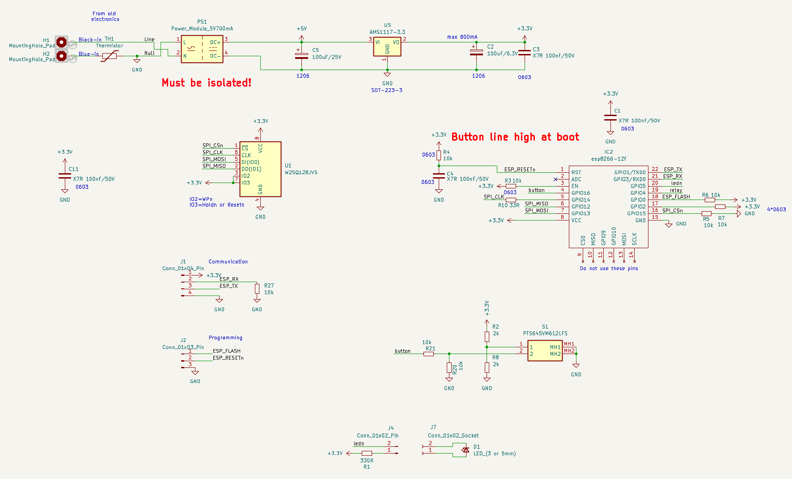
Figure 4. Schematic of the electronics for the KostalPiko
The schematic shows the connections to the ESP8266, Flash device, button and LED.

Webpages
Most of the settings for the KostalPiko Reader can be done by using the webpages. Also, information about already made settings is shown by the webpages.
Every web page has:
- Title specific for the page
- Green buttons that can be used to make a setting active or open another webpage
- Date and time are shown.
- Button to go back to the main page (except main page)
- Button to logout

The following webpages are created:

Main webpage (index.html)
This page starts when the IP number of the device is entered in the browser. First a login is needed to prevent unauthorized access of the KostalPiko Reader.
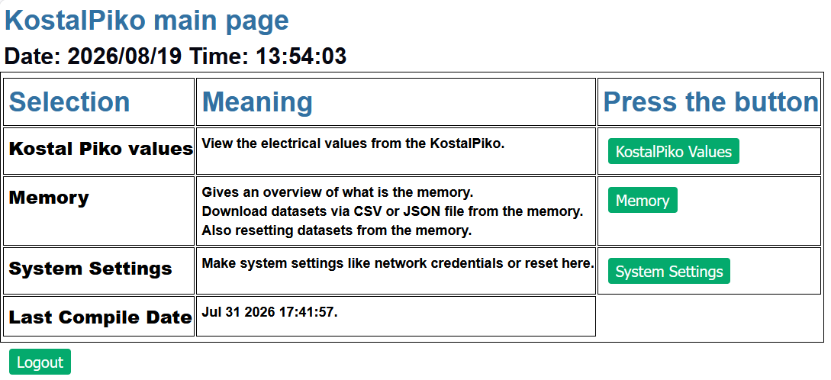
Figure 5. Main webpage of the KostalPiko Reader
On this webpage some important settings can be found like:
- Link to KostalPiko energy values
- Link to memory filling and download/remove of values
- Link to system settings
- Last compile Date & Time.
- Logout button
The following subpages are defined and reachable by buttons on the main page.

KostalPiko_values
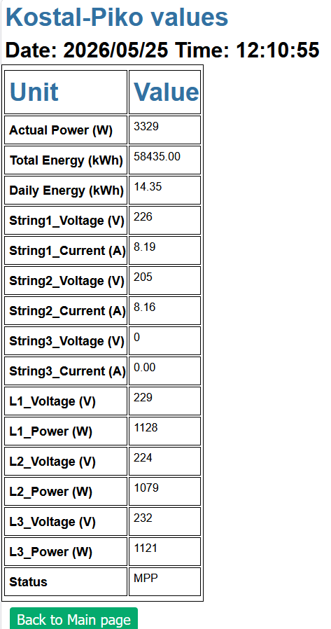
On this webpage values are shown from the KostalPiko device. The following values are shown:
- Actual/Current Power (W)
- Total Energy (kWh)
- Daily Energy (kWh)
- String1 Voltage (V)
- String1 Current (A)
- String2 Voltage (V)
- String2 Current (A)
- String3 Voltage (V)
- String3 Current (A)
- L1_voltage (V)
- L1_power (W)
- L2_voltage (V)
- L2_power (W)
- L3_voltage (V)
- L3_power (W)
- Status of the KostalPiko device

Figure 6. Kostal-Piko values

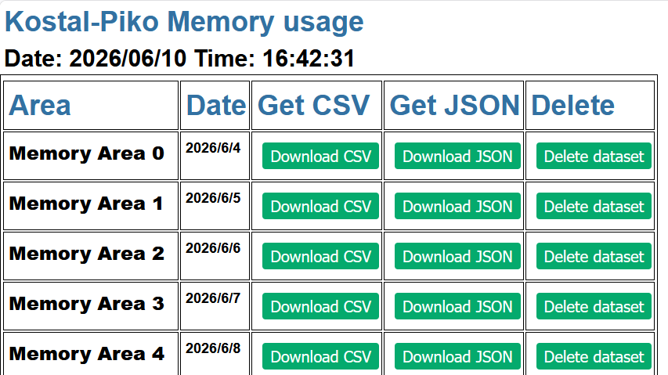
Memory
Shows a list of all the dates, of which values are available.
Three types of buttons are shown for every item.
- Download CSV file
- Download JSON file
- Delete dataset

Figure 7. Memory filling of the Kostal-Piko

KostalPiko Settings webpage
On this webpage settings can be made for:
- Network credentials for Sign-in, Wifi, MQTT and KostalPiko device
- Reset Device
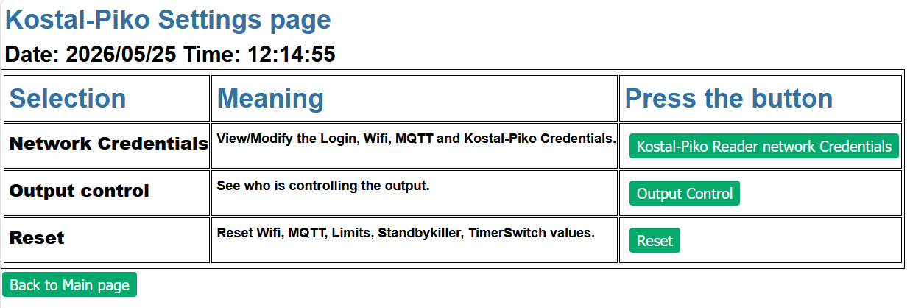
Figure 8. Webpage for system settings

KostalPiko Reader network credentials
Via this webpage “KostalPiko Reader network Credentials”, Settings can be viewed and/or changed. Default view is with passwords replaced by ****. Use the “Toggle ..” button to view the passwords.
If the user wants to change settings for the credentials, then there are 4 buttons:
- Modify Sign-in Credentials
- Modify Wifi Credentials
- Modify MQTT Credentials
- Modify KostalPiko credentials
Using these buttons will open other webpages where the credentials can be changed. After saving the credentials, the KostalPiko will restart.
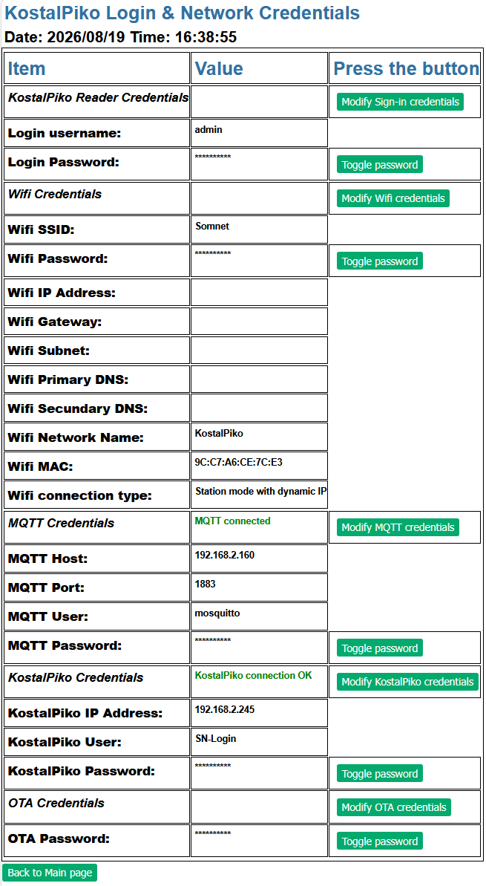

To access the KostalPiko Device credentials are available.

For Wifi connection Wifi Credentials can be set

If a user does not have a MQTT broker running, these credentials can be left untouched.

Select Modify KostalPiko.. to get access to the KostalPiko device

OTA credentials are for a save way to update the software in the KostalPiko reader.
Figure 9. Showing network credentials

Reset
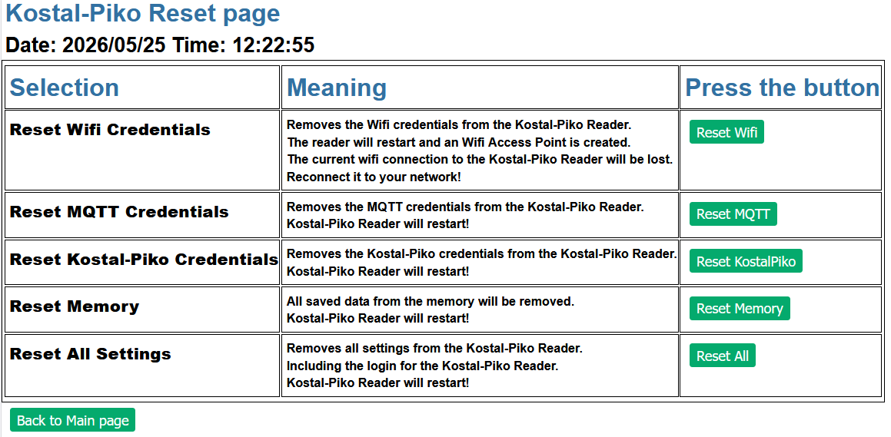
Figure 10. Reset several parts of the KostalPiko
The following selections for reset are possible:
- Reset Wifi credentials.
- Reset MQTT credentials.
- Reset all credentials.
- Reset Memory.
- Reset All Settings.

Login manager
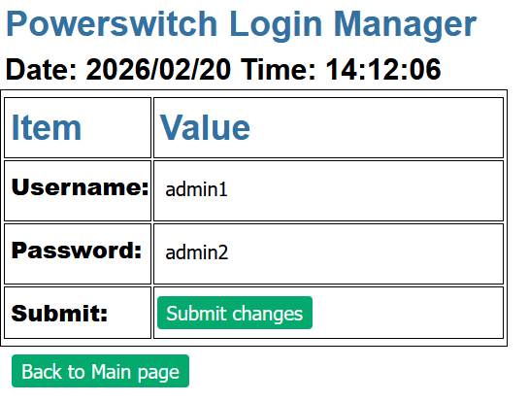
Access to the KostalPiko Reader is protected by a username and password. This prevents unauthorized access to the KostalPiko Reader. At the start or after a full reset both terms are set to “admin”. The user should change these. Simply fill in a new Username and Password and press “Submit Changes”. The KostalPiko will restart, close the browser and open it again. Now the user can login with the new credentials.
Figure 11. Changing the login credentials

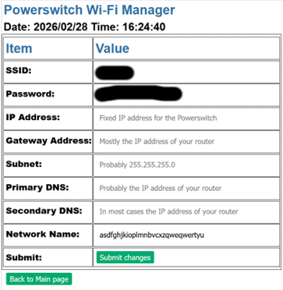
WifiManager
Figure 12. Settings for Wifi
This webpage can be used to set the Wifi credentials. There is a choice if the KostalPiko needs a fixed IP number of a dynamic IP number assigned by the router. This according to the following rules:
- If an IP number, gateway, subnet and PrimaryDNS are given, a connection with static IP number will be created.
- If an IP number, gateway or subnet are missing, a connection with dynamic IP will be created.
- For any other condition an Access Point will be created.
Wifi network name is limited to 30 characters
After these credentials are filled-in, the KostalPiko will restart and tries to connect to the network given in the credentials.
The type of connection that is created will be shown in the “System Settings” page
Keep in mind that the “Network Name” is used as device name on the internet and for for CSV and JSON download names.

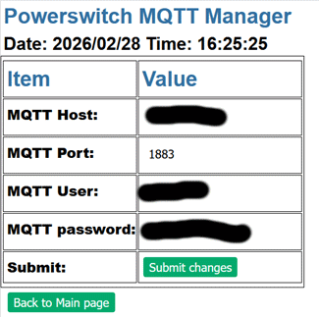
MQTTManager
Figure 13. MQTT settings
If the user has an MQTT server running, connection can be made to this MQTT server. Credentials like: IP and Port number and also user and password need to be filled in. After filling-in the credentials the KostalPiko will restart and tries to connect to the MQTT server with the given credentials.
The settings for the MQTT connection will be shown in the “System Settings”-“KostalPiko network Credentials” page.
If the user does not have a MQTT server these items can be left blank.

Webpage hierarchy
Webpage | Sub page
Index (main) | KostalPiko_values
 | memory
 | system settings
 |  | show_wifi_mqtt_credentials
 |  |  | login
 |  |  | wifimanager
 |  |  | toggle_wifi_password
 |  |  | mqttmanager
 |  |  | toggle_mqtt_password
 |  | reset
 |  |  | Reset Wifi/MQTT
 |  |  | Reset Memory
 |  |  | Reset All

Webpages are in html.
A “style.css” file is used to hold information about styles of the html pages.
A file “favicon.ico” that holds a small picture (16 x 16 pixels) that will be shown in the browser address line.

OTA programming
OTA programming is possible for the KostalPiko Reader
- Uploading firmware is protected by a password. Arduino IDE asks for the password.
- Uploading new datafiles to LittleFS has a problem. Arduino IDE does not ask for a password. A workaround for this can the removal of the OTA password. Don’t forget to add a password again.

ESP8266-12 (ESP8266MOD) pinning

Module pin no | Signal name | Alternative name
1 | RST | Used for reset button | ESP_RESET
2 | ADC | ADC input | Not used
3 | EN | Pulled high | High
4 | GPIO16 | High on boot (as output?) Used as input | Button
5 | GPIO14 | SPI-SCLK | Flash clock
6 | GPIO12 | SPI-MISO | Data to flash
7 | GPIO13 | SPI-MOSI | Data from flash
8 | VCC | POWER | 3.3Volt
9 | CS0 | GPIO11 | Do not use them, they are used for the internal flash chip of the ESP8266 module.
10 | MISO | GPIO7
11 | GPIO9 | High on boot
12 | GPIO10 | High on boot
13 | MOSI | GPIO8
14 | SCLK | GPIO6
15 | GND | GROUND | Ground
16 | GPIO15 | SPI-CS | CSn to flash
17 | GPIO2 | High on boot
18 | GPIO0 | FLASH button | ESP_FLASH
19 | GPIO4 | n.c.
20 | GPIO5 | Low will switch the LED on | Ledn
21 | RXD0 | GPIO3/high on boot | Debug-TX
22 | TXD0 | GPIO1/high on boot | Debug-RX

First Start of the KostalPiko Reader
When you first start with the KostalPiko Reader, the reader does not have any knowledge of your home network, KostalPiko Device and mqtt credentials.

Fully erase the KostalPiko Reader
To be sure that you start with a clean KostalPiko Reader:
- Plugin the device, wait until you see two flashes of the led. Now the Reader startup is completed.
- Press the button for 5 seconds. The LED will flash every second. Release the button after the fifth flash. The Reader will erase all settings and clears the flash memory.
- Wait for the restart of the Reader and the two LED flashes.

Connecting to your home network
- If the Reader is not connected to a network (does not have any credentials), it creates its own network.
- Use a mobile device (telephone, tablet or laptop) and look into the wifi networks. There must be a network called “KostalPiko_xxxx” (xxxx = a random number). Connect to this network.
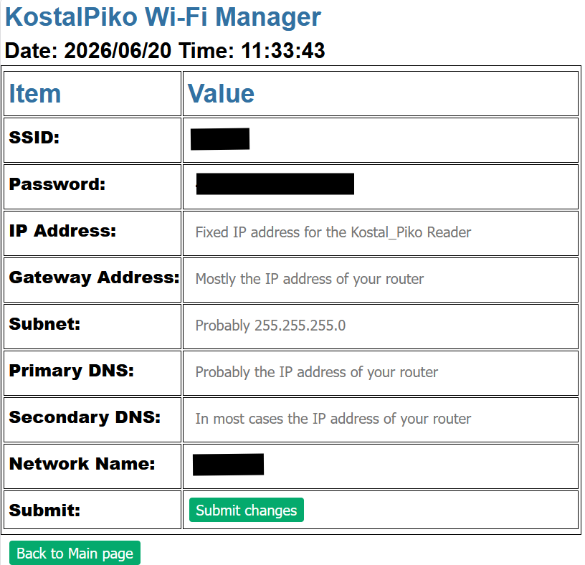
- Now go with your webbrowser to http://192.168.4.1/wifimanager.html
Figure 14. Setting Wifi credentials
- A login username and password are asked. They are not set, so click “Signin”.
- You will get a webpage as shown on the right side.
- Fill-in at least your SSID, Password and Network name if you want to give the Reader a dynamic IP address.
- If you want to give the Reader a static IP address, you also have to fill-in the other items.
- Press “Submit changes” when you are done and want to use the given values.
- Press “Back to Main page” if you don’t want to make changes to the Wifi settings.
- When you submit the changes, the values will be saved and the Reader will restart and will connect to your home network.
- Find your Reader now in your own network, by entering the IP address of your Reader in your internet browser.
- From the main page go to page “System Settings” & “Kostal-Piko Reader network Credentials”
- You will see that there is no connection to the KostalPiko device (red text).
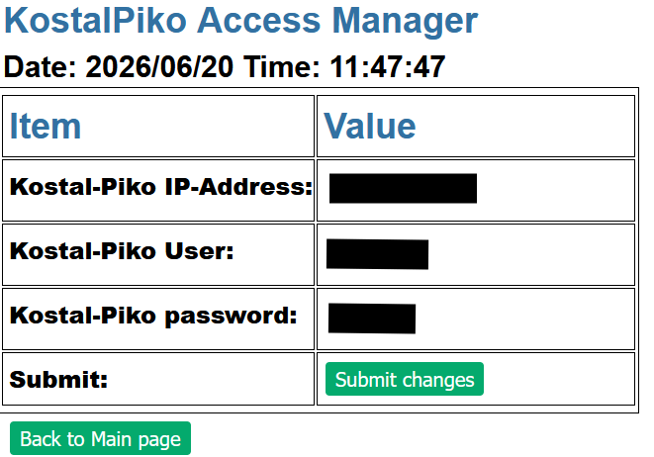
- Click on “Modify KostalPiko credentials”.
- Now you can enter the IP address of your KostalPiko device, a username and a password. See the next picture
- If OK click on “Submit changes”.
- Again, the Reader will restart will try to connect to the KostalPiko device
- Now go to the main page of the website of the Reader in select “System Settings” & “Kostal-Piko Reader network Credentials”.
- Check the KostalPiko credentials and you should see in green “KostalPiko connection OK”
Figure 15. Setting KostalPiko credentials
- If you see text in red again, then the connection is not successful.

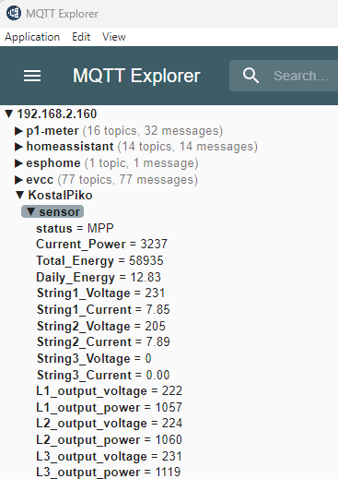
Figure 17. Connection to KostalPiko device
Figure 16. Published MQTT values
- If you have an MQTT server running, you can set the MQTT credentials in the same way.
- If don’t have an MQTT server running or don’t know what MQTT is, leave these fields untouched
- Picture on the right show what values are published

- To prevent unauthorized access to the KostalPiko Reader you can add a login username and password.
- The KostalPiko Reader can be reprogrammed over the air (OTA). To prevent unauthorized reprogramming a password can be set via “OTA Password”.

YAML file settings for Home Assistant
Under
mqtt:
sensor:
place
#
# Kostal Piko Solar inverter
#
# Power & Energy
- name: "Current_Power"
state_topic: "KostalPiko/sensor/Current_Power/state"
unique_id: "KP_CurPow"
unit_of_measurement: W
device_class: "power"
state_class: "measurement"
"device": {
"identifiers": ["kostalpiko"],
"name": "Kostal Piko",
"model": "Piko",
"manufacturer": "Kostal"
}
- name: Total_Energy
state_topic: "KostalPiko/sensor/Total_Energy/state"
unique_id: "KP_TotEne"
unit_of_measurement: kWh
device_class: "energy"
state_class: "total_increasing"
"device": {
"identifiers": ["kostalpiko"],
"name": "Kostal Piko",
"model": "Piko",
"manufacturer": "Kostal"
}
- name: "Daily Energy"
state_topic: "KostalPiko/sensor/Daily_Energy/state"
unique_id: "KP_DaiEne"
unit_of_measurement: kWh
device_class: "energy"
state_class: "total"
"device": {
"identifiers": ["kostalpiko"],
"name": "Kostal Piko",
"model": "Piko",
"manufacturer": "Kostal"
}
# string1
- name: "String1_Voltage"
state_topic: "KostalPiko/sensor/String1_Voltage/state"
unique_id: "KP_Str1_V"
unit_of_measurement: V
device_class: "voltage"
state_class: "measurement"
"device": {
"identifiers": ["kostalpiko"],
"name": "Kostal Piko",
"model": "Piko",
"manufacturer": "Kostal"
}
- name: "String1_Current"
state_topic: "KostalPiko/sensor/String1_Current/state"
unique_id: "KP_Str1_A"
unit_of_measurement: A
device_class: "current"
state_class: "measurement"
"device": {
"identifiers": ["kostalpiko"],
"name": "Kostal Piko",
"model": "Piko",
"manufacturer": "Kostal"
}
#string2
- name: "String2_Voltage"
state_topic: "KostalPiko/sensor/String2_Voltage/state"
unique_id: "KP_Str2_V"
unit_of_measurement: V
device_class: "voltage"
state_class: "measurement"
"device": {
"identifiers": ["kostalpiko"],
"name": "Kostal Piko",
"model": "Piko",
"manufacturer": "Kostal"
}
- name: "String2_Current"
state_topic: "KostalPiko/sensor/String2_Current/state"
unique_id: "KP_Str2_A"
unit_of_measurement: A
device_class: "current"
state_class: "measurement"
"device": {
"identifiers": ["kostalpiko"],
"name": "Kostal Piko",
"model": "Piko",
"manufacturer": "Kostal"
}
# L1
- name: "L1_output_Voltage"
state_topic: "KostalPiko/sensor/L1_output_voltage/state"
unique_id: "KP_L1_Volt"
unit_of_measurement: V
device_class: "voltage"
state_class: "measurement"
"device": {
"identifiers": ["kostalpiko"],
"name": "Kostal Piko",
"model": "Piko",
"manufacturer": "Kostal"
}
- name: "L1_output_Power"
state_topic: "KostalPiko/sensor/L1_output_power/state"
unique_id: "KP_L1_Pow"
unit_of_measurement: W
device_class: "power"
state_class: "measurement"
"device": {
"identifiers": ["kostalpiko"],
"name": "Kostal Piko",
"model": "Piko",
"manufacturer": "Kostal"
}
# L2
- name: "L2_output_Voltage"
state_topic: "KostalPiko/sensor/L2_output_voltage/state"
unique_id: "KP_L2_Volt"
unit_of_measurement: V
device_class: "voltage"
state_class: "measurement"
"device": {
"identifiers": ["kostalpiko"],
"name": "Kostal Piko",
"model": "Piko",
"manufacturer": "Kostal"
}
- name: "L2_output_Power"
state_topic: "KostalPiko/sensor/L2_output_power/state"
unique_id: "KP_L2_Pow"
unit_of_measurement: W
device_class: "power"
state_class: "measurement"
"device": {
"identifiers": ["kostalpiko"],
"name": "Kostal Piko",
"model": "Piko",
"manufacturer": "Kostal"
}
#L3
- name: "L3_output_Voltage"
state_topic: "KostalPiko/sensor/L3_output_voltage/state"
unique_id: "KP_L3_Volt"
unit_of_measurement: V
device_class: "voltage"
state_class: "measurement"
"device": {
"identifiers": ["kostalpiko"],
"name": "Kostal Piko",
"model": "Piko",
"manufacturer": "Kostal"
}
- name: "L3_output_Power"
state_topic: "KostalPiko/sensor/L3_output_power/state"
unique_id: "KP_L3_Pow"
unit_of_measurement: W
device_class: "power"
state_class: "measurement"
"device": {
"identifiers": ["kostalpiko"],
"name": "Kostal Piko",
"model": "Piko",
"manufacturer": "Kostal"
}
# status
- name: "Kostal-Piko_Status"
state_topic: "KostalPiko/sensor/status/state"
unique_id: "KP_status"
"device": {
"identifiers": ["kostalpiko"],
"name": "Kostal Piko",
"model": "Piko",
"manufacturer": "Kostal"
}
# http code
- name: "Kostal-Piko_code"
state_topic: "KostalPiko/sensor/kostalpiko_code/state"
unique_id: "KP_code"
"device": {
"identifiers": ["kostalpiko"],
"name": "Kostal Piko",
"model": "Piko",
"manufacturer": "Kostal"
}
- name: base_Total_Energy
state_topic: "KostalPiko/sensor/base_Total_Energy/state"
unique_id: "KP_Base_TotEne"
unit_of_measurement: kWh
device_class: "energy"
state_class: "total_increasing"
"device": {
"identifiers": ["kostalpiko"],
"name": "Kostal Piko",
"model": "Piko",
"manufacturer": "Kostal"
}
- name: out_Total_Energy
state_topic: "KostalPiko/sensor/out_Total_Energy/state"
unique_id: "KP_out_TotEne"
unit_of_measurement: kWh
device_class: "energy"
state_class: "total_increasing"
"device": {
"identifiers": ["kostalpiko"],
"name": "Kostal Piko",
"model": "Piko",
"manufacturer": "Kostal"
}
- name: "out_Daily Energy"
state_topic: "KostalPiko/sensor/out_Daily_Energy/state"
unique_id: "KP_out_DaiEne"
unit_of_measurement: kWh
device_class: "energy"
state_class: "total"
"device": {
"identifiers": ["kostalpiko"],
"name": "Kostal Piko",
"model": "Piko",
"manufacturer": "Kostal"
}

Values in Home-assistant
I have created an item under Overview with all the KostalPiko values
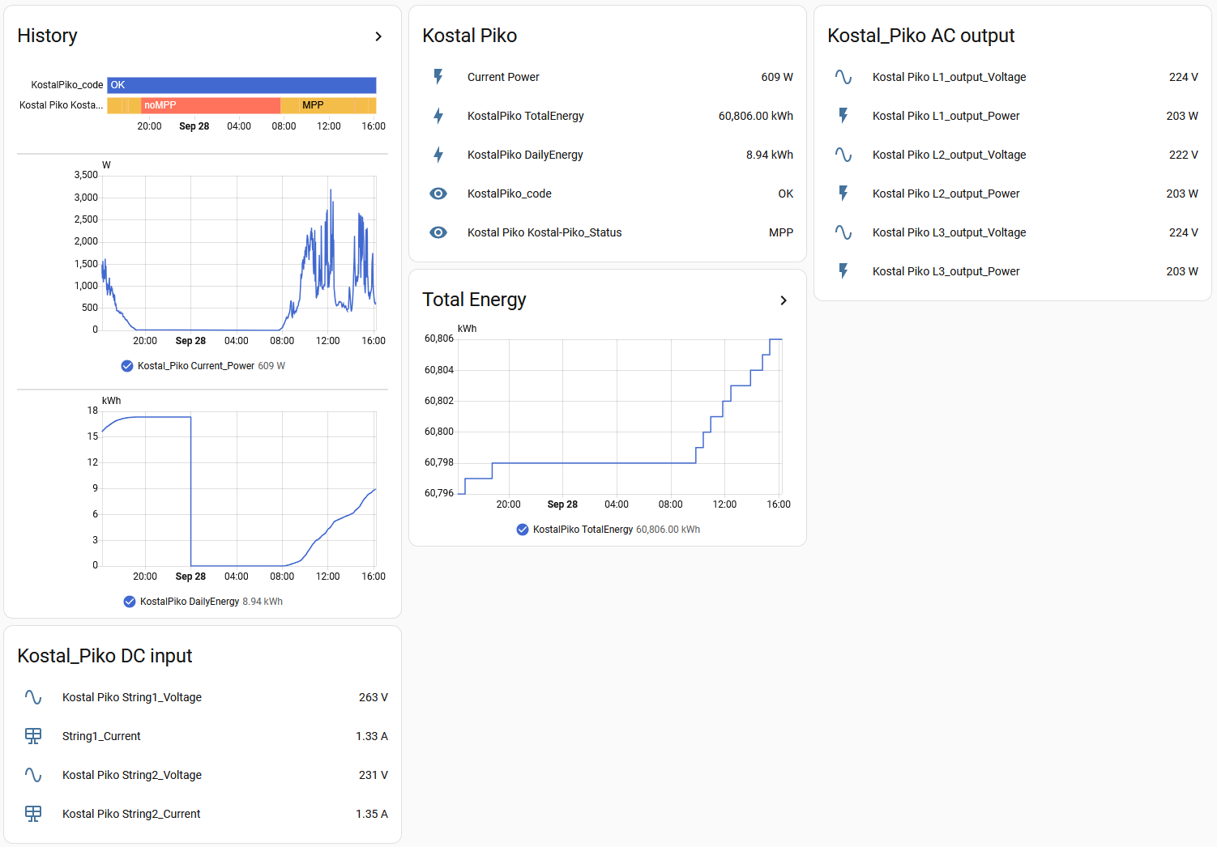
Figure 18. KostalPiko values in Home Assistant
Also created a link for direct access to the KostalPiko Reader website
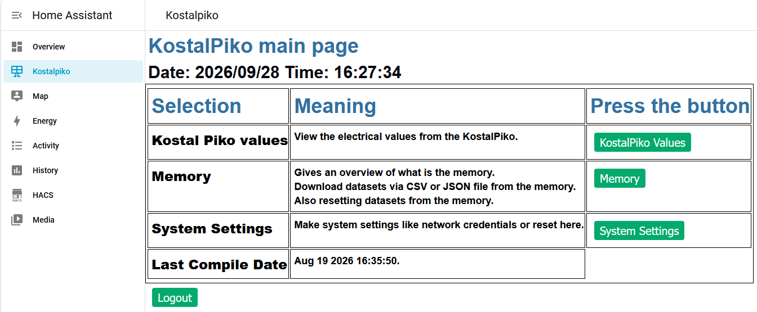
Figure 19. Direct access to KostalPiko Reader website

Used libraries/plugin’s in Arduino IDE

- AsyncMqttClient, Marvon Roger
https://github.com/marvinroger/async-mqtt-client
- Ethernet, Arduino
https://www.arduino.cc/en/Reference/Ethernet
- ESP_Async_Webserver, Mathieu Carbou
https://github.com/mathieucarbou/ESPAsyncWebServer
- ESP_AsyncTCP, me-no-dev
https://github.com/me-no-dev/ESPAsyncTCP
- FloattoAscii, Koen de Vleeshauwer
https://github.com/koendv/FloatToAscii
- NTPClient, Fabrice Weinberg
https://github.com/arduino-libraries/NTPClient
- Time, Paul Stoffregen (Arduino)
https://playground.arduino.cc/Code/Time/
- Timezone, Jack Christensen
https://github.com/JChristensen/Timezone
- EspSoftwareSerial, Dirk Kaar
https://github.com/plerup/espsoftwareserial/
- SPIMemory
https://github.com/Marzogh/SPIMemory

Littlefs upload, For uploading HTML, CSS, JS and text files
Download file: arduino-littlefs-upload-1.6.2.vsix
Place in: C:\Users\<user>\.arduinoIDE\plugins
In Arduino use CTRL-SHIFT-P and choose: “Upload Littlefs..”
Serial Monitor must be switched off
Use flash and reset button on the ESP module if needed.

ESP Exception decoder
For debugging:
- EspExceptionDecoder
https://github.com/me-no-dev/EspExceptionDecoder

Problems/To do
Network
- Networkname not correct in STA mode with Fixed IP.
in AP mode Networkname KostalPiko_xxxx, OK! Seen on Phone
In STA mode with dynamic IP?. Networkname is correct! Seen In Fritzbox, Eset does not recognize the networkname, keeps even old IP number.
Send bug report.
Wifi credentials with ssid and password and subnet not working. Should be dynamic IP
Status page
- Button
  - Filenames still as fixed txt in cpp code. Also in progmem.h.

